MRIBCSS2025
Call For Abstract

- Submission Deadline: October 30, 2025, 23:59 China Standard Time (CST)
- Author Notification: Early November 2025
- Submission Website: https://www.tscss.org.cn/meeting/CSS/

The Magnetic Resonance Imaging Branch of the China Society for Stereology (MRIBCSS) invites abstract submissions for its 2025 Annual Conference. The event will be held from November 21-23 in Ningbo, China, at the Ningbo International Conference Center on Dongqian Lake. The conference aims to advance MRI academic exchange, develop future talent, and promote the translation of technology into practice.
We invite abstracts presenting new and original research on a variety of MRI-related topics. Submitted abstracts may overlap with concurrent submissions to other conferences (e.g., ISMRM). Authors must specify one of the following session categories for their abstract:
- Ultra High Field
- Quantitative Myocardium
- Hyperpolarized Spins
- Chemical Exchange Saturation Transfer (CEST)
- Quantitative Susceptibility Mapping (QSM)
- AI For Recon
- AI For Postprocessing
- Vascular Imaging
- Perfusion
- Diffusion
- MRI Hardware
- Clinical Applications
- Multi-Modal & Multi-Dimensional MRI
- Animal MRI
- Low Field MRI
- Spectroscopy And Multi-Nuclei Imaging
- Motion Correction
- Guided Therapy And Safety
- Multi-Posture MRI
- Others
Submitted Guidance
- Abstracts must be submitted as WORD files.
- The manuscript must adhere to the ISMRM abstract format requirements (detailed below).
- All abstracts must be submitted online.
Word Limits
The following word limits will apply:
- The entire document must be limited to a single page
- Title: 125 characters
- Body of the Abstract: 750 words (references not included)
- Figures: up to 5 only for abstract
- Figure Captions: 500 characters per caption

Suggested Abstract Format

We recommend including the following sections, although we also note that there are often good reasons to deviate from this format.
- INTRODUCTION: "Why was this study/research performed? What unsolved problem are you addressing?"
- METHODS: "How did you study this problem?"
- RESULTS: "Report the data, analyses and/or outcomes"
- DISCUSSION: "How do you interpret the results?"
- CONCLUSION: "What is the relevance to clinical practice or future research?"
- REFERENCES: Cite each source in numerical order using superscript Arabic numerals.
Please refer to the example abstract page suggested below.

A Novel Imaging Methodology
F. Last Name One¹, F. Last Name Two¹, and F. Last Name Three¹
¹Institution Name, City, State, Country
INTRODUCTION:
[Your introduction text here]

METHODS:
[Your method text here]

RESULTS
[Your method and results text here]

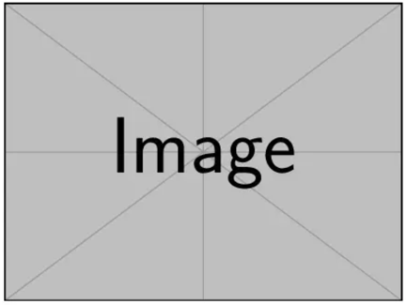
Fig.1 (a) Gold Standard (b) Proposed Method (c) Baseline Method

DISCUSSION:
[Your discussion and conclusion text here]

CONCLUSION:
[Your discussion and conclusion text here]

REFERENCES:
[1] [Your reference here] [2] [Your reference here]

